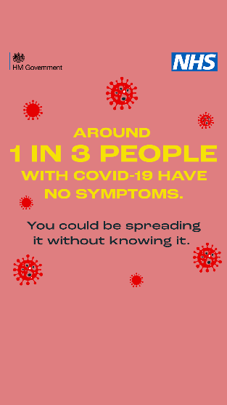
INSERT CORPORATE LOGO

COVID 19 Alert

“The NHS is open but under immense pressure and may soon run out of capacity. We all have a duty to protect ourselves and our colleagues at work and at home. Please join me and have a coronavirus test.
Identifying people who are carrying the virus but not showing any symptoms, will help us reduce transmission rates.”
[insert name of CEO/MD

Covid Testing Unit for our staff, contactors, vendors and construction workers from Wednesday 3rd February 2020

Did you know that one in three people who have Covid-19 do not have any symptoms?

This is called being asymptomatic. Any one of us could have the virus and not know it, yet still be transmitting it to others. The best way of identifying anyone who has the virus but has no symptoms is to conduct Lateral Flow Testing (LFT).

The LFT requires a swab from your throat and nose, which is placed into a tube and developed at the testing site. Trained staff will be in the testing unit to assist you.

To support you and your colleagues at work (and your families/friends at home), a test site has been established on the Slough Trading Estate at 951 Yeovil Road so you can get tested. The test takes just a few minutes and you’ll get the results back in about 30-60 minutes by email or text from NHS Test and Trace. That’s all it takes. Rock up and get tested. To be most effective, you need to be tested 2 times per week. You can book here:

https://outlook.office365.com/owa/calendar/LFTCurve@slough.gov.uk/bookings/

Please remember to follow social distancing of 2m and only enter the test area when it is safe to do so. And you must be free of Covid-19 symptoms before having your test.

Let’s all do our bit to keep our great company running and keep you, your fellow workers and your friends and family at home, safe. I’m counting on you!

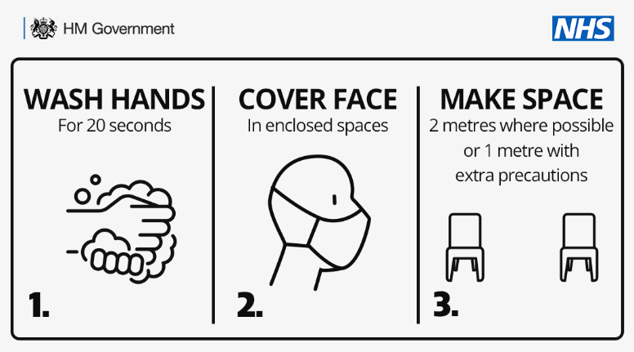

Results of your test

Positive LFT
Anyone who tests positive will have to self-isolate and be prepared to be contacted by NHS Test and Trace and/or our Local Contact Tracing Service.

It is imperative that you and your contacts self-isolate at home for at least 10 days, and anyone in your household or support bubble must self-isolate for 10 days, away from friends and family.

- Follow the government’s guidance on self-isolation here.
- Ensure you follow the instructions and guidance provided by NHS Test and Trace when they get in touch to identify your contacts.

This is an important step in breaking the chain of transmission. If you test negative, you can return to work.

Negative LFT
If your LFT is negative, you should continue to follow the government’s guidelines on how to protect yourself and your family from coronavirus, including regularly washing your hands with soap for 20 seconds, wearing a face covering in enclosed spaces and staying at least 2m apart from anyone not in your household or support bubble.

LFT testing is for people who do not have Covid-19 symptoms. Remember, if you do have symptoms you can get a free test by going online or calling 119.

WHAT ABOUT TIME OFF WORK AND PAY?
